**TRACKING TABLE**

|  |  |  |  |
| --- | --- | --- | --- |
| **No** | **Page** | **Amendments** | **Effective date** |
|  |  | ….. | …. |
|  |  |  |  |
|  |  |  |  |
|  |  |  |  |
|  |  |  |  |

|  |  |  |  |  |
| --- | --- | --- | --- | --- |
|  | **Editor** | **Review** | | **Approve** |
| **Signature** |  |  |  |  |
|  |  |

# SUMMARY

1. **Purpose**

For example:

* Describe the steps of implementation and management in software outsourcing activities of units in Viettel Peru Company. Manage and evaluate the quality and progress of oursource work from request to completion of outsourcing.

1. **Applied** **object**

For example:

* Apply for all software development activities new or upgrade that are performed by external partners.
* All software products are purchased from external partners for Viettel Peru to manage business and **upgrade later**. Before acceptance with partner, Department (it means Department in charge purchasing product) must coordinate with the IT Division to evaluate documents, source code, and program and **get approving by IT Division about product meets all requirements according to regulations of Viettel Peru** (detailed requirements on **Acceptance Item** of this process).

1. **Responsibility**

For example:

* All Departments are responsible for compliance and correct implementation of the steps in the process. Management of outsource software projects must comply with the regulations of Viettel Peru.
* During the working process, Departments provide information within the scope of work, **don’t provide/allow** partners to access all project information or other information of the Company, Customers and other internal products.
* The **Process Department** periodically **audits** the compliance regulations and instructions of all Departments.

1. **Related document**

|  |  |  |
| --- | --- | --- |
| **No** | **Document** | **Effective date** |
| 1 | Statement about using BPMN language to draw process 11698/TTr-Process | 28/11/2022 |
|  | … |  |
|  |  |  |

1. **Definitions and Terms**

|  |  |  |
| --- | --- | --- |
| **No** | **Term** | **Explain** |
|  | … |  |

1. **Flow chart**

For example:

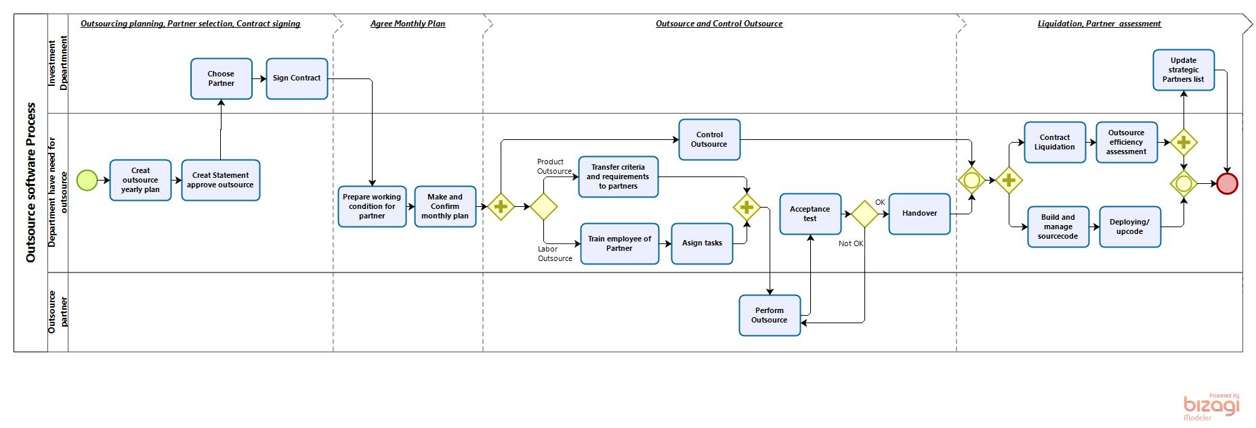

**Flowchart, detailed description of each Step, Input, Output, Teamplates of this Process at:** ………………..This is link of storing process on server which Process deparment send to Promulgate Department.

1. **Brief description**

Must describe all step of flowchart, this is example:

| **No** | **Step** | **Brief description** |
| --- | --- | --- |
|  | Creat outsource yearly plan | Based on the outsourcing needs of Viettel Peru (including inside and outside the IT division), Development Department creats outsourcing plan for the year. The rate of **labor outsourcing** is **not over 20%** of total outsourcing for optimize management cost. |
|  | Creat Statement approve outsource | Development Department make Statement for getting approve by CEO about ousouce needs os next year. |
|  | Choose Partner | Investment Department coordinates with Department have need for outsource to select outsourced partners in accordance with the Company's regular procurement regulations. |
|  | Sign Contract | Investment Department coordinates with Department have need for outsource to make contract with **SLA** about plan and quality, Criteria for products that outsource partners need to ensure are stated in **Appendix 01** |
|  | Prepare working condition for partner | Before starting, Department have need for outsource makes a commitment to information security for Viettel Peru and requires the legal representative of the partner to sign the commitment in accordance with Form **F02**. |
|  | Make and monthly plan | - Department have need for outsource make Monthly plan according to form **F.03** and get confirm and agrees on the monthly plan by partner: for **n+1 month** must be agreed and sign monthly plan with outsource partner **before 28th of the month n**.  - **Warning**: When working with a partner, **don’t send detailed effort files** or **estimation method** to Outsource partners to avoid revealing jars of sensitive information. |
|  | Transfer criteria and requirements to partners | **Apply to Product Outsource:** Department have need for outsource hands over documents for outsourcing work to the partner after agreeing on the monthly plan and before the partner starts to perform the work. |
|  | Train employee of Partner | **Apply to Labor Outsource:** Department have need for outsource hands over documents for outsourcing work to the partner after agreeing on the monthly plan. |
|  | Control Outsource | **Apply to Product Outsource:** Department have need for outsource monitors progress, evaluates the quality of the partner's performance.  **Apply to Labor Outsource:** Every month at the latest on the **10th of the month n,** Department have need for outsource makes a report to evaluate the completion results and workday results of the outsourced partner according to the assignment of the **month n-**1. |
|  | Asign tasks (apply to Labor outsource) | **After apply to Labor outsource:** After training outsourced personnel, Department have need for outsource assigns and evaluates performance of outsourced personnel |
|  | Perform Outsource | Outsourced partner performs the work as agreed in the contract, finalized monthly plan and/or according to assignment task if Labor outsouce. |
|  | Acceptance test | Based on the time of acceptance commit with Request Department on RF, Department make acceptance test plan with outsource partner and invite Request Department join **Program demo session** by Outsource partner. |
|  | Handover | - Immediately after the successful acceptance, Department have need for outsource performs:  + Receive handover from the outsourced partner the documents, sources that have been successfully accepted in Step 12.  + Sign with the partner the handover minutes according to the form **F.01**. |
|  | Build and manage sourcecode | Department have need for outsource build source code which recive form outsource partner and then store source code on SVN. |
|  | Contract Liquidation | Department have need for outsource must finish all procedure for contract liquidation according to regulation of Company. |
|  | Outsource efficiency assessment | After **maximum 5 working days** from the end of outsourcing contract, Department have need for outsource must evaluate responsiveness and must be **approved in writing by CIO** according to Appendix 02 |
|  | Deploying/ upcode | Department have need for outsource upcode according to PROCESS.VTP.IT.02. |
|  | Update strategic Partners list | Investment Department update with Partners, if with bad results: **point ≤ 70** will not be selected for the next outsourcing activity. |

1. **Appendix**

For example:

**Form:**

* Handover from Partner to Viettel Peru_F01.
* Commitment to require Outsource partner keep information confidential for Viettel Peru_F02.
* Estimate effort for Outsource_F.03 (Internal use only, Don't send Outsource Partner).
* Monthly plan_F.04.

**Appendix**

* Technical Criteria attached to Contract with Outsource Partner_Appendix 01.
* Criteria for evaluating effectiveness of Outsource partner when finish contract_Appendix 02.